**Training classifier with different feature**

**Mouqing Jin**

Classifier: SVM

Custom concepts to be trained:

Dribbling, Dunk, Freethrows, Shooting

1: Hog (Histogram of oriented gradient) Feature

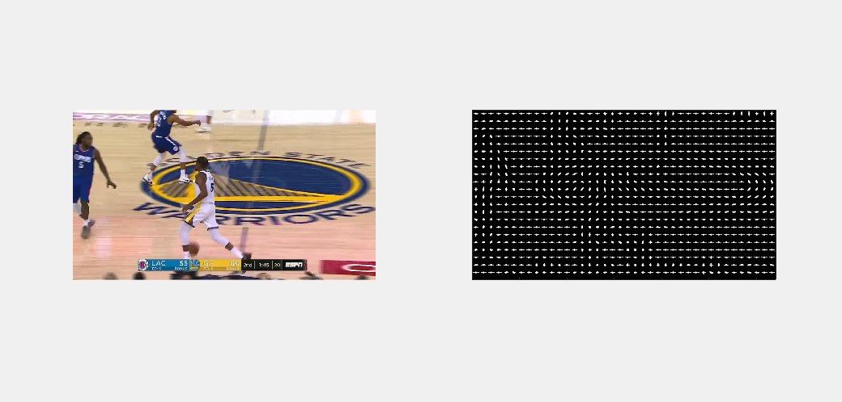

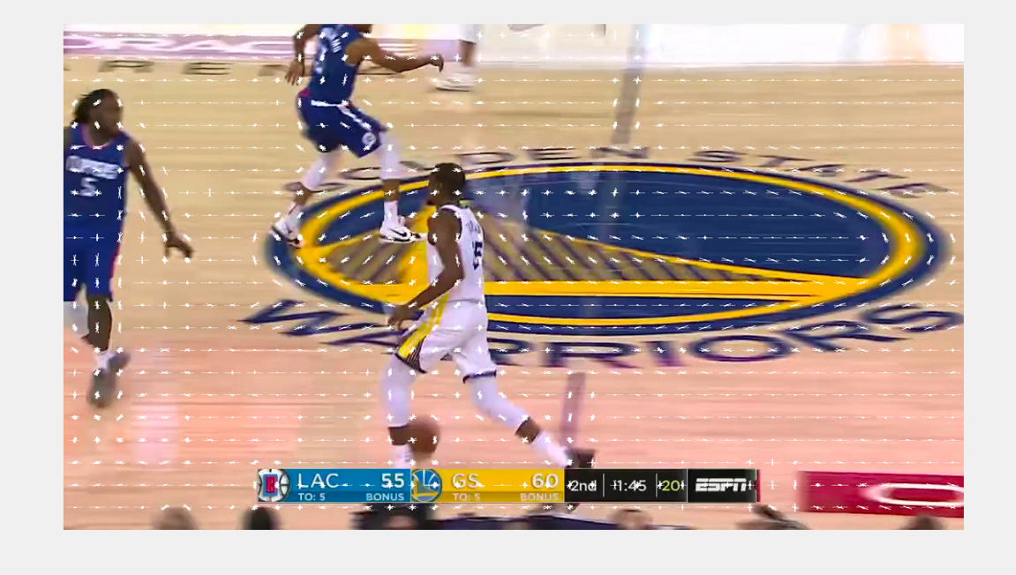

Training result:

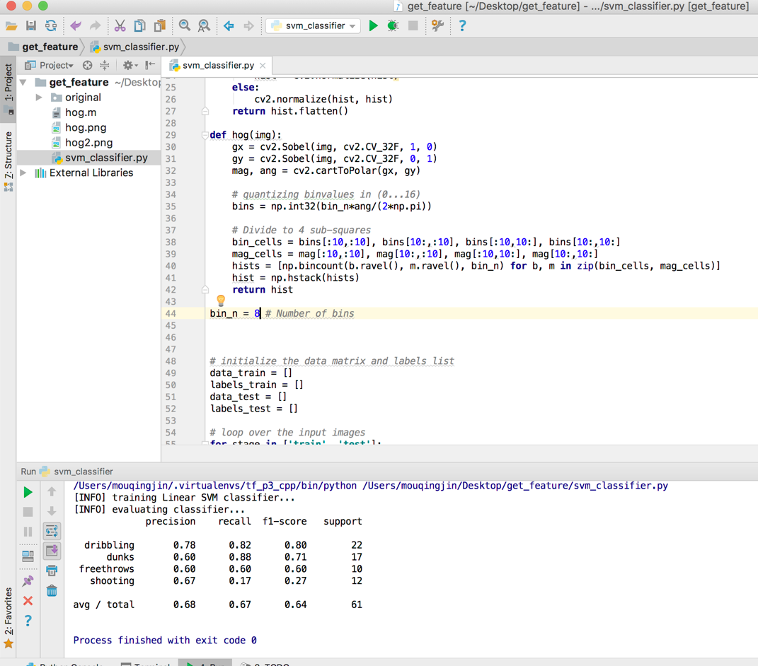

2: LBP (Local Binary Patterns)

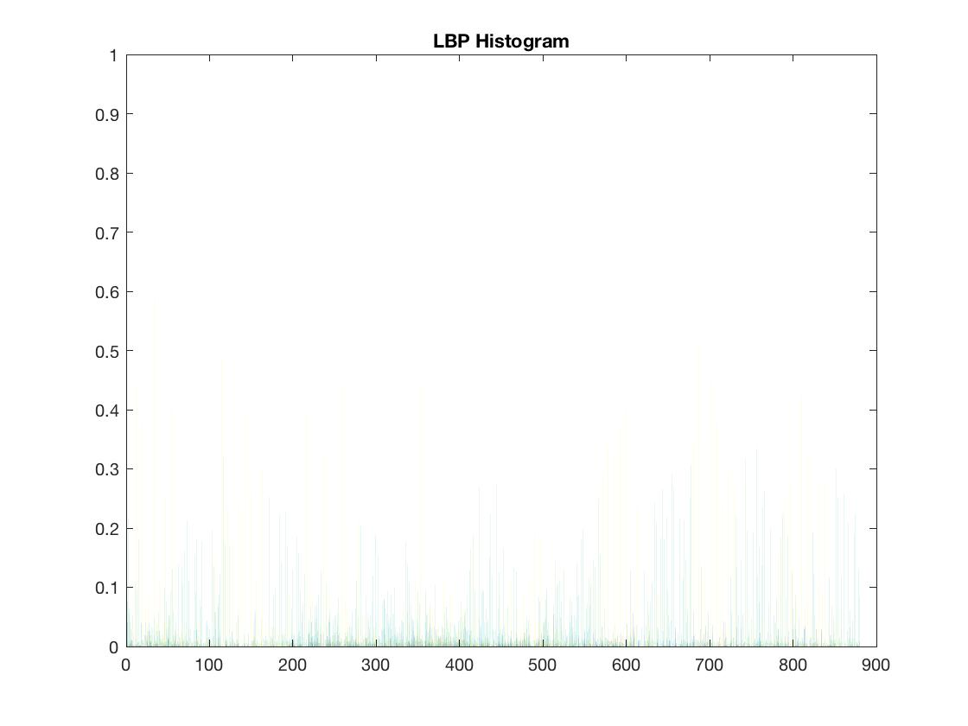\\

Training result:

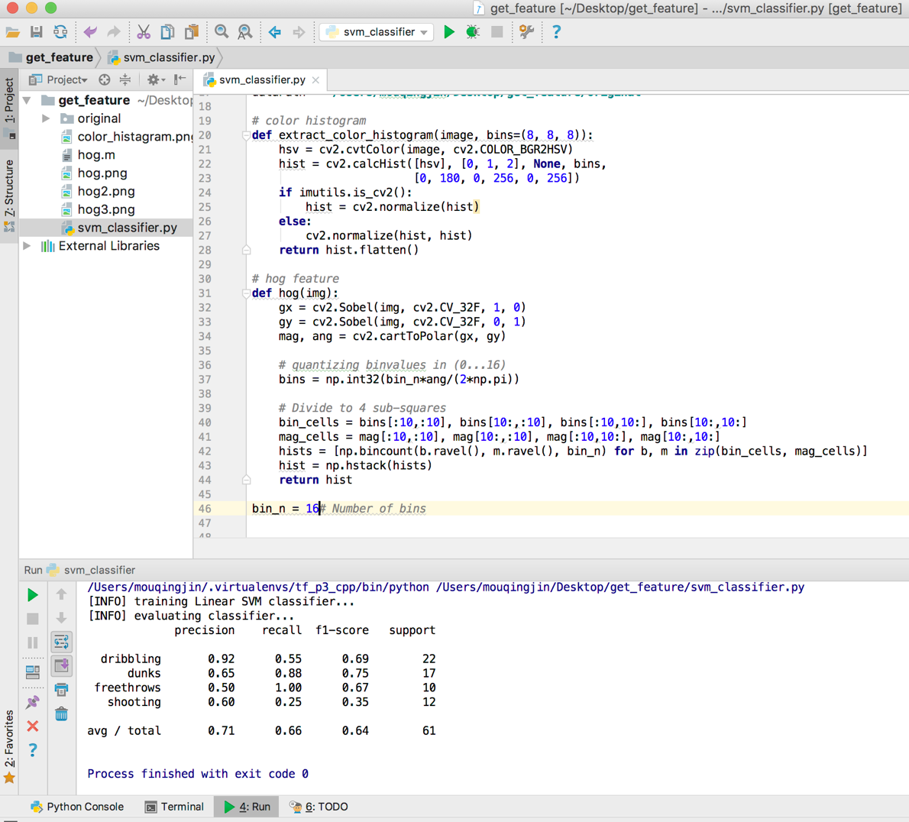

3: Color histogram

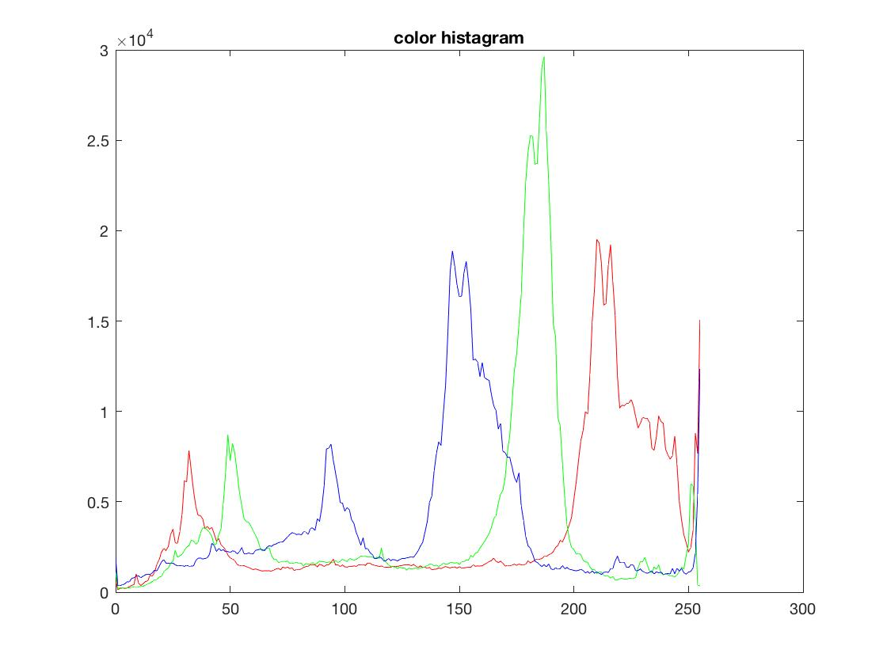

Training result

